Physics simulation software
This is the second project in my testing on the 4 main methodologies and how they effect a project, I am also using this study as an attempt to learn and grow by recognising where I am making development harder for myself. Previously, I made an AI project capable of recognising different numbers in images with a spiral methodology, I would recommend looking at the document made for that project before looking at this.
Recently, I started the second year of mechanics in my maths A level, and to be frank, I am struggling. This project will be focused on simulating real life mechanics in the unity game engine to both improve my understanding of the mathematical concepts within mechanics and attempt the application of a different methodology. However, that is quite a broad area to cover. Specifically, I would like to create a program where I can throw a ball and watch it interact with various objects – such as slopes and walls. There will however be copious limits on how this is implemented, I have not learnt the entirety of mechanics year 2 yet nor have I started learning further mechanics. I will have to abstract many features to ensure that the simulation does not become too complicated.
But before I begin on development, I must first choose the methodology that I will use throughout the process. The 4 methodologies are: waterfall, Rapid Application Development, Agile and spiral. As I have already used spiral, I will have to choose from the first 3. I have already described in detail each of these methodologies yet will briefly recap their pros and cons.
Waterfall
- great for time management
- keeps the project very organised
- extremely rigid
- the final project will likely not be exactly as wanted
Rapid Application Development (RAD)
- extremely flexible
- focuses on usability
- requires constant communication with client (or evaluation in this case)
- not suited to larger projects
Agile
- extremely flexible
- focuses on code quality and efficiency
- difficult to control
- communication issues within larger teams (not an issue for me)

I can see a viewpoint behind why I could use each of these, but there is one main thing I want to achieve with the methodology chosen. I want to not spend too long on this project. with coursework, homework, revision, work experience, open days and everything in my life currently, it would simply not be feasible for this project to be as large as my last one. I therefore narrow my choice down to RAD, which is suited to smaller projects, and waterfall, which is great for time management. Due to a requirement of organisation, I will be choosing waterfall for this project.

Feasibility study
As I stated in my previous document, waterfall begins with a feasibility study. I will now analyse this project with a template designed from public feasibility studies online. I found that feasibility studies typically have 5 main points, however I skipped economic and legal feasibility as I believe they do not apply to this project.

Technical Feasibility – correct equipment
The largest concern with technical feasibility is in how I program the project. If I simulate in too much detail then it may cause intense lag and will need much stronger hardware to handle. However, I really doubt that I will reach that point, the current knowledge that I have will already limit me greatly in how I handle this project and calculations will not be particularly large. Despite this, it is something to consider throughout development – especially in code efficiency.

Operational feasibility – correct knowledge
As I have already stated, I do not have all of the required knowledge to create this project to a life-like degree. However, that is not the requirement of this project, the requirement is to create a project that highlights the features of the waterfall methodology and to improve my understanding of mechanics inside maths. Now, this does not mean I will stick to purely my own knowledge, as that would lead to the research stage being completely unnecessary. I will research new topics to add to the solution yet ideally nothing outside of my specification in mechanics and further mechanics.

Time feasibility – available time
Time feasibility was an extremely large concern initially, as I had previously stated. Waterfall will hopefully mean that I make the most use out of the time I can provide, this does however still mean that I will be taking away slightly from my time spent on schoolwork to complete this project. In the same way as my last project, I must be aware that any drops in my grades or understanding inside school due to this project will cause it to be suspended immediately. Despite these harsh constraints, I believe that it is extremely possible to complete this project in the time frame of this month with good planning and organising.

My final conclusion is that yes, this project is risky in terms of knowledge and time feasibility but this simply must be taken into account as I work on the project. It is a much better idea to recognise these issues now and prepare for them potentially worsening later.
With this done, I can now begin on the actual development of the project. The project will follow the typical waterfall structure of Analysis, design, implementation, evaluation. To ensure that my time is spent most efficiently as I work, I will write down each part of the project that I will be working on and the time that I would like that section to be finished by.

Time planning
For reference, it is currently the 6th of May as I write this. The project MUST be finished by the end of the month. I will plan the project to take up the entire month as a worst case scenario but aim to complete it more quickly than that.
Analysis
- I create a rough outline of what the final program will look line and include
- I describe necessary requirements for the project
- I perform research into any parts of the project that I am unsure of
- Must be completed by the 12th May
Design
- I create a finished outline of what the final program will look like and include
- I design each algorithm inside the project
- I describe how I will make the project look
- I state how I will test the project’
- Must be completed by the 18th May
Implementation
- I turn my planned algorithms into finished code inside the project
- I take screenshots of the process and state why I am making each choice
- I test the project as I make it, ensuring as little errors as possible
- I translate the design into a finished appearance of the project
- Must be completed by the 26th May
Evaluation
- I evaluate the project and where it could be improved
- I add any gaping features I believe should be implemented
- I test the project with all kinds of inputs to ensure it works as intended
- Must be completed by the 31st May

I believe that this plan is most definitely possible. I will likely be spending no longer than an hour on the project per day and I think that this framework would still work even if I were to spend only half an hour per day. I will have to wait and see if the project takes longer than intended but I realistically believe it will be finished around May 22nd -However, This does not mean I will rush the project to complete it by that time.

Analysis
Firstly, I would like to give a more detailed explanation of the planned end product thus far. I will go through and bullet point each major feature of the solution.
- The player sees in a first character perspective. They are able to move their screen around 360 degrees however they are unable to actually move.
- The player is able to throw a ball by holding down left click and releasing. The longer that left click is held down for, the more power behind the throw
- The ball when thrown will be given an initial velocity
- The ball will contain a list of forces that are acting upon it at any given point.
  - When moving on the floor, friction will act on it.
  - When touching any surface there will be a normal reaction force
  - Gravity will constantly be acting on the ball
  - (other forces may be added depending on research)
- Forces will be used to calculate a vector for acceleration that will be applied to the ball
- The player will be contained within a room filled with slopes, objects and walls to test and throw the ball against
And that is the base plan for this project. I would like to add more forces for more realism as the project continues but we will simply have to see as time moves on. I’m also considering the possibility of the ball rolling instead of just acting like a particle.
I firstly want to look through the rest of the mechanics this year that I haven’t done yet. If there is anything simplistic that will assist in the realism of project, then I would like to see if it is possible to learn quickly. Sadly however, I was unable to find anything in the textbooks for pure mechanics and further mechanics that would relate to this project.
I decided to look into the potential of the ball rolling only to find degree level physics that simply would not be beneficial for me to learn in the slightest. Instead, I will increase the complexity slightly by adding more forces to the program as I mentioned earlier. air resistance and buoyant force are the two ill add. This means the ball will slow down in the air and will bounce when it comes into contact with surfaces
I will now begin research, research for this project will begin slightly differently than how I would normally handle it. Instead, I want to focus on reaffirming my mechanical knowledge and ensuring there are no inconsistencies.

Research - forces
- Friction – currently, I believe that the way friction works is that it will act in an opposite direction from the direction of movement on the ground. It will have a max value called Fmax, if the newtons of the force opposing the friction is lower than this, the ball will not be able to move as the friction will be equal and opposite to the resultant force. Once the force exceeds Fmax, the friction will remain at Fmax, still reducing the acceleration of the ball whilst allowing it to move. Fmax is calculated by the product of the reaction force on the ground and the frictional coefficient (which will likely be a constant between 1 and 0 in this case)
  - Confirmation: my research matches up with this perfectly. Nothing is askew
- Gravity – is extremely simple, the force of gravity (weight) will always be directly downwards and is calculated with: mass * g (where g = 9.8 and mass is in kg) due to how acceleration is calculated, this will cause any object in free fall to fall with an acceleration of 9.8ms⁻²
  - Confirmation: this does hold true, however in real life situations it could be beneficial to use a more precise value of g at 9.81 ms⁻²
- Normal reaction – the normal reaction force is what stops objects from going through walls and falling through tables. The normal reaction force will only be greater than 0 when two objects are touching. it will act on the moveable object perpendicular to the surface with a magnitude equivalent to the force going in the direction of the surface.
  - Confirmation: this will work for my program, however the normal reaction force can apparently be changed by other factors such as the object they are colliding with moving. I don’t intend to add this feature so I should be completely fine.
- Air resistance – I am unsure of how air resistance works as we do not go through it in typical mechanics. I think it would likely just be a constant force that’s opposite to the direction of motion whilst moving.
  - I found interesting information about air resistance (or better known as drag). it apparently scales quadratically with velocity, meaning a higher velocity will cause more air resistance.
  - The formula for calculating drag in one dimension is: drag = drag constant * velocity^2
  - drag constant will just be a constant in between 1 and 0 that I play around with for a nice value.
  - Velocity will be calculated every update() tick anyway so will just need to be accessed for this formula. The issue however is that by squaring the velocity, I could potentially completely change the direction the air resistance it is travelling in. This will likely be addressed in design.
  - It should also be noted that the air resistance will be in in the opposite direction to the direction of movement.
- Buoyant force – I have a basic understanding of how this would be implemented but not how it works in the real world. My plan would be to just multiply the velocity by a value in between -1 and 0, 0 causing no rebound at all and -1 causing a rebound of the same force
  - Apparently, this is practically how it does work, the value I mentioned is called COR or e and reduces the velocity by a set amount. I can’t find much online about calculating e without having the velocity before and after, so I will just set it as a constant value and play around with it.
- My plan to calculate acceleration and velocity is to use F = ma - newtons second law. I will provide a constant value to the ball as a mass and then rearrange the formula for acceleration a = f / m. I will then apply the acceleration every update() to the velocity (scaled by time.deltatime to make it essentially happen per second)
  - Thankfully, as this is a very fundamental part of the project, I found nothing online disproving this approach

Research – necessary code
In the AI project, I discovered that creating a code bank of everything that I may need was extremely beneficial, and so I decided that I would create a code bank in this project also. However, I did not need to research much code as I have used unity so often in the past.
Below is what I felt as if I needed to research, it includes Object oriented techniques as I believe I will use OOP to create each ball.
GameObject.CreatePrimitive(PrimitiveType.Sphere); - Will allow me to make a new sphere, essentially making a new ball in code.
Public class stuff : MonoBehaviour { public stuff()} – creates a new class alongside a constructor method
mathf.repeat(a, length) – wraps a value around a certain length and is very useful for angles in 3D

Success criteria
This success criteria will be used in evaluation to ensure that I have completed the project fully without error
- The ball has a class
- A new object of the ball can be created in run time
- The ball can be thrown
- The player is contained within a room with enough variation to be interesting
- The player is able to look around 360 degrees
- The ball has forces that act on it (this must include gravity, the force of the throw friction and the normal reaction force)
- The forces that act on the ball will give it an acceleration
- Acceleration is applied every update tick (scaled by time.deltatime) to the velocity
- The velocity is set every update tick to the ball game object
- Balls on the floor will be removed when a new one is thrown

What will NOT be added
- Rotation of the ball
- Any more forces than have been priorly researched
- Moving platforms or objects
- Different objects having different frictional coefficients
With all this information highlighted, I will now move onto design. It is currently May 9th as of writing this, meaning I am on track. I am quite happy with how quickly analysis was finished, I am concerned that I was not thorough enough, yet I simply cannot see what else would be necessary to analyse.
I will however likely have to take more research in design that focuses on system architecture and the actual code itself. From what I have seen online, I have found nothing that states this is not allowed in waterfall.

Design
I decided the first part of design that I would focus on would be designing each algorithm as I feel as if a new outline of the final program would not particularly help me in any way.

Ball Class
- Attributes
  - Private Vector3 acceleration
  - Private Dictionary<String, Vector3>() forces
  - Private List<Collision> touchingObjects
  - Public Vector3 velocity = (0, 0, 0)
  - Public float mass
  - Public float reboundForce
  - Public float frictionCoefficient
  - Public float COR
- Methods
  - Ball()
    - The constructor method for the class
    - Will create the gameobject for the ball
    - Will take the initial velocity as a parameter and set it to the velocity variable
    - Will take the position as a parameter and set it to the game objects position
  - getResultantForce()
    - helper function for other methods
    - returns the resultant force of the ball by summing all forces together
  - onCollisionEnter()
    - will run when the ball enters another colliders hitbox
    - adds the collision to the list touchingObjects
  - onCollisionExit()
    - will run when the ball exits another colliders hitbox
    - removes the collision with this colliders name from touchingObjects
  - ApplyReactionForce()
    - Will only run if touchingObjects is not empty
    - For each collision in touchingObjects:
      - will sum every single force together to get the resultant force
      - will get the normal of the plane that the ball collided with
      - will dot the sum of all forces with the negative of the normal and add it to the list of forces with the name:
      - touchingObject + “Reaction”
  - ApplyFriction()
    - Will only run if touchingObjects is not empty
    - For each collision in touchingObjects
      - The negative of the resultant force is calculated.
      - The normal of the plane is gotten from the collision
      - the ProjectOnPlane function is used to get the direction the ball is travelling in parallel to the plane
      - if the magnitude of this force is less than Fmax (reaction force * friction coefficient) then the negative of this force is applied as friction
      - if not, the negative of this force normalised is multiplied by Fmax and applied
      - the name of the friction applied will be:
      - touchingObject + “Friction”
  - ApplyAirRes()
    - Creates a new vector with the same values as the current velocity
    - Multiplies the vector against the absolute value of itself and then the drag coefficient
    - Negates the vector and adds it to forces with the name “airRes”
  - ApplyBounce()
    - Will only run if touchingObjects is not empty
    - For each collision in touchingObjects
      - The reaction force is gotten for that object
      - will get the velocity of the ball
      - will get the normal of the plane that the ball collided with
      - will dot the velocity with the negative of the normal
      - A new vector variable is calculated from the product of this vector and COR
      - This is applied to the object with the name:
      - touchingObject + “bounce”
  - updateVectors()
    - all forces are summed up and divided by the mass to get the acceleration
    - this then has the vector (0, -9.81, 0) added to it to account for gravity
    - this is set to the acceleration variable
    - the velocity variable has the acceleration variable added to it
    - the ball is translated by the velocity * time.deltatime
PlayerView script
Public float sensitivity
Public int maxVerticalAngle
- Mouse input
  - The character the player is using (which will likely just be a capsule) will be rotated by the sensitivity * the horizontal mouse input around the y axis
  - The camera will be rotated by the sensitivity * the vertical mouse input around the x axis
  - The camera’s x axis rotation will then be clamped with the clampView() function
- Angle wrapping
  - Currently I am unsure of how the angle wrapping will work as angles have wrapped very inconsistently for me in the past. It may not even be necessary in this case.
  - If values exceed a certain threshold I will set them to a reduced but equal angle such as 360 degrees to 0 degrees or 180 degrees to -180 degrees
  - This will likely happen in the Update() void
- clampView() method
  - The camera will not be able to move up any further if its rotation is greater than (maxVerticalAngle) degrees up from the horizontal
  - the camera will also not be able to move down further if its rotation is greater than (maxVerticalAngle) degrees down from the horizontal

BallThrow script
Ball currentBall = null
Float throwingForce = 0
Public float ballDistance = 1
Boolean throwing = False
- Inputs to throw the ball
  - If “throwing” is false and if the left click button is pushed down
    - Throwing becomes true
  - If throwing is true and the left click button is held down
    - The throwing force has time.deltatime added to it
  - If throwing is true and left click button is not held down
    - A new instance of the ball is created (see below) and throwing is set to false
- Creating a new instance of a ball
  - The object in the currentBall variable is deleted and the variable set to null
  - A vector is created with the x rotation of the camera and y rotation of the character
  - The vector is turned into a direction vector with a formula I found online
  - quaternion.euler(vector) * Vector3.forward
  - this direction vector is then multiplied by the throwing force to get the velocity
  - the direction vector is then given an initial position by multiplying the ball by the ballDistance to get the position of the ball in front of the player
  - A new instance of the Ball class is created with the velocity and position previously calculated
  - The currentBall variable is set to this instance

WHAT HAD TO BE RESEARCHED
- getting the normal of a plane
- projection plane
- calculating drag in 3 dimensions
- getting the direction vector from the rotation vector

Now with a base understanding of the inner structure of the solution, I would like to briefly discuss the appearance of the program. Appearance is not a large focus of this solution as I want to focus more on the programming, implementation and understanding instead.
However, I will not neglect the appearance entirely, I will likely do subtle changes to make the program more usable. Such as using a different colour for the room in comparison to the ball or using a material I find online to make the room look much more interesting.
In terms of the room itself, it will likely just be a hollow cube around the player, about the size of 20 balls in each dimension. It will contain slopes, random blocks and objects hanging off the ceiling. If I have time, I’m even considering adding a basketball hoop to make the balls forces used in a more enjoyable manner.
With this out of the way, it is time to discuss testing. Testing is not something that I have properly done in any of my past projects, even the AI project did not have correct testing. That is why I really want to put some effort into the testing of this project – that way I will learn new skills and improve my debugging. The below structure is the same as in my computing NEA:
Testing during development
- The first thing that will be developed is the script to allow the player / camera to look around. This will be tested by checking the mouse input in each cardinal direction and ensuring the mouse moves accordingly
- The max angle the camera looks at should be capped at a configurable angle. I should check each cardinal direction after this has been implemented to ensure it has not affected other parts of turning and has correctly capped the angle
- I will then develop the ability to throw the ball. I will check every axis negative and positive to see if the ball is correctly thrown in that direction with a correct initial velocity and correct initial position
- With this done, just before developing forces I will design the room with a tool such as probuilder. The room should be tested to some extent to ensure there are no holes and that the lighting allows for the player to see
- each force will be developed in an order that allows me to test them much easier
  - gravity first as it will impact all forces to some extent
  - then the normal reaction force so that the ball won’t fall through the floor
  - then friction as it requires the reaction force
  - then the buoyant force as it is easy to implement
  - then the air resistance last as it is not necessary for the program
- I will not move on until I have met certain criteria for each force
  - Gravity – the ball must consistently accelerate 9.8 ms⁻²
  - Reaction force – the ball must stop on the ground, on slopes, on walls and in situations where it touches to objects at once
  - Friction – the ball must slow down over time whilst touching the floor and the ball should be unable to move as long as the resultant force is less than Fmax
  - Buoyant – the ball should bounce a configurable height when it touches the floor
  - Air resistance – the ball should slow down in the air and the ball should slow down faster if it is travelling faster

Post development testing
- I will repeat the exact same steps as I did throughout development, making note of any errors and fixing them as quick as I possibly can.
- I make sure that I follow the same order as I did in development, as I will need to check that features added first were not broken by features added much later
Acceptance testing
- As I do not have a client or end-user, I will thankfully not have to send this project to anybody to check that it meets the criteria correctly
- However, I will still have to go through acceptance testing myself
- Firstly, I will look through the success criteria made in analysis, if the success criteria is completed then I can move on
- Next, I will look at my initial goals for the project as stated in the first few paragraphs of this document.
- Finally, I will analyse how polished the final solution feels. If I feel as if it feels nice enough to use and accurately depicts forces, I will move on and consider the project finished

And that marks the end of design as noted in my analysis section. I found the design much trickier than analysis, which seems to ring true for all projects I have completed as of late (especially by computing NEA). However, I do not feel as if the design was rushed in any way at all and am quite happy with it. I am writing this as of 13/05, which is a whole 5 days ahead of schedule, I have also been writing for only about half an hour each day yet am getting an extremely large amount of content down. I feel as If my skill at planning and writing is improving. Now with an actual plan, its time to move onto implementation.
IMPLEMENTATION
I immediately began the implementation stage by setting out a basic scene and creating the “player” – a capsule with the main camera kept at head height
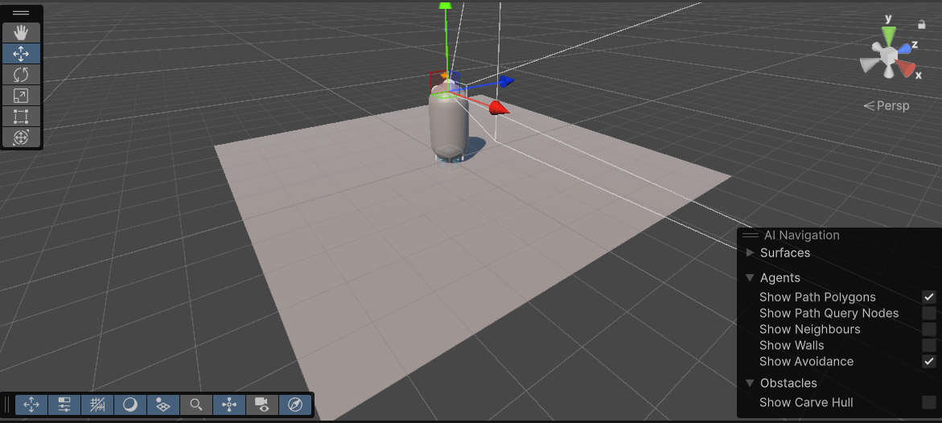
This now meant that I could move onto the programming of the camera movement as stated in my testing strategies.
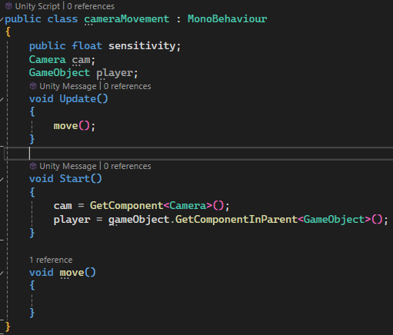
I created a new folder called “scripts” and inside created the script cameraMovement.cs. I began by laying out the groundwork for the script with all necessary variables.

I decided to not make the camera and player variables public as to not clutter the inspector menu and attempts a new approach. This forced me to fill the values in the start() method as seen.
Next, I had to move the camera by the “Mouse X” and “Mouse Y” inputs.
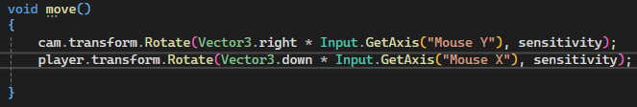
I believed this was simple enough to achieve, however testing raised errors.
The camera would constantly rotate, and inputs were not being recognised. I decided to print both camera and player to see if they specifically were null.
I found that the camera was correctly detected however the player was null. I had never taken an approach like I had before to fetch the parent, It had most certainly not worked how I had intended. I found an error at the top of the list.

Using this, I drafted up some new code. By instead using Transform instead of GameObject, I believed that the code would work. Thankfully, I stopped getting the same error, however I now faced the logic error of rotations being applied extremely strangely. Now, the camera was rotating on all axis at once, at the very least it responded to inputs.
I found that by multiplying sensitivity instead and negating the mouse X input, I would get a much nicer result. However, I couldn’t help but notice that all operations applied on the player variable were in reality being applied to the camera itself. If I instead used a public variable to store the player, It would work perfectly as intended. For the sake of trying to understand the problem though, I decided to continue with this approach.
By printing the variable, I could confirm my suspicion that the camera was actually being stored within the player variable. Upon searching up what GetComponentInParent does, I found the root of the problem.
My assumption was that it found the component in the parent alone, however it actually searches the current game object first for the same component. With this in mind and some new code to get the parent game object itself, I was back on track.

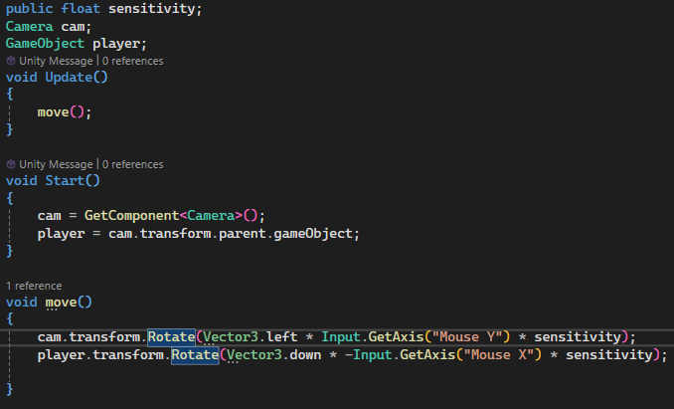
This was the current state of the script – working perfectly as intended.
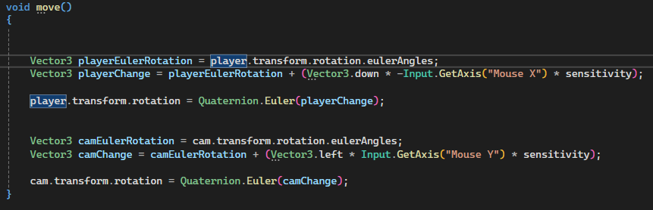
I however did not like how this was laid out for clamping values, as I would have to clamp after I had already rotated. I shifted from using the rotate() function to setting the rotation manually myself.

Now I could move onto clamping. Below is my first attempt at the clamping method. I created a new variable called maxVerticalAngle as I stated in my design and tried this
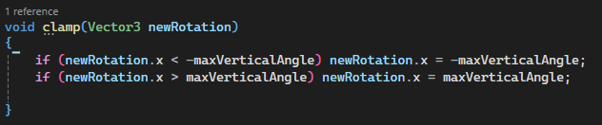
However, passing variables by reference did not work how I imagined so I had to recode the method to instead be a function.
This worked correctly for stopping the camera when it moved to low but not when it moved too high. Instead it would snap my camera downwards every time I attempted to look higher than straight ahead.
I printed the rotation in the code every update() and found that it was wrapping in a way that was different from the inspector. I had seen this issue before and decided to use the mathf.repeat function, I decided the same approach here would be suitable.
It took an extremely long time, but I managed to get the program working with non-variable values. I found these values by observing the angle as I moved up and down with a print(). I found that looking straight ahead was 180 / -180, looking straight down was -90 and looking straight up was 90.
the way this works is that if I have a max angle value of 80, I need to stop the value from getting any higher than 100 and lower than -100, however I could not just use that alone as either statement would run in any situation.
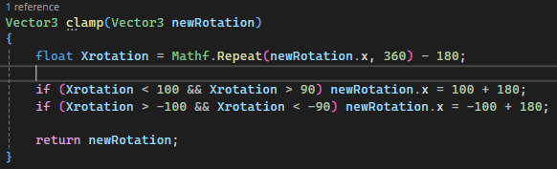
To fix this, I added an additional statement to ensure that they would only run at the correct time. I then set the rotation to the max it can be in the area with 180 added - as I had previously subtracted 180 from the Xrotation variable.

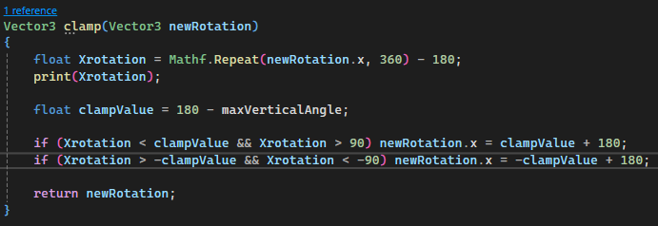
Now I had to change these values to work for the max angle variable. This thankfully did not take nearly as long.

I could now customise the viewing angle for the player very easily. i settled on using 70 as the maxVerticalAngle, as it felt extremely similar to what typical games would have.
I then added the finishing touches of making the cursor disappear and locking the cursor to the centre of the screen before adding comments.
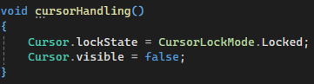
I then performed the testing I had previously stated. Finding the code to work perfectly, I could now move on to creating the ball class and giving it an initial velocity.
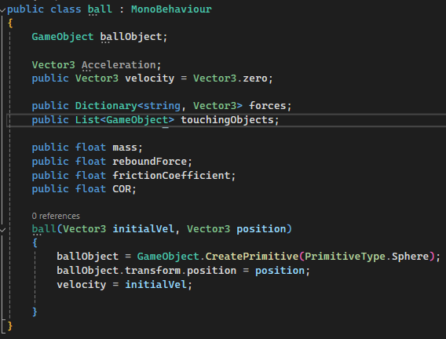
I started by creating two new scripts. The script to throw the ball (ballThrow.cs) and the script to contain the class of the ball (ball.cs). it made the most sense to me to create the ball class first before moving onto the class to spawn in balls.

I started by creating the initial aspects of the class. The variables and constructor method. All variables mentioned here are the same as in my design, par the ballObject variable, which I added to track the gameObject the script was attached to. As I considered the script more, I realized I was quite confused as to how it would actually run. I had not used classes very often in the past and thus didn’t know if start or update would run when this class was made.
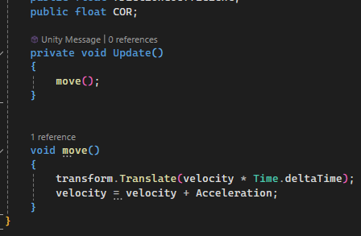
I found online that it was actually quite bad practice to use a constructor to begin with. Instead, I should create the gameObject in the ballThrow script and put the script onto that game object instead. I shifted to this approach and decided to create a basic system for the ball to move by velocity and accelerate by acceleration, that way, I could test the ballThrow script.

I now started on the ballThrow script by equally laying out the variables and methods.
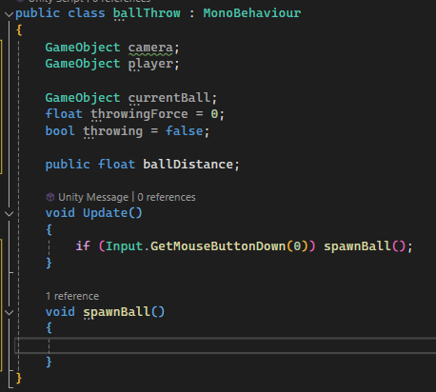
I decided that it would be beneficial to begin by using left click to spawn the ball. This would make it much easier to test as I program
I had to add the variables of the camera and the player as they will be necessary for deciding the direction the player is facing.
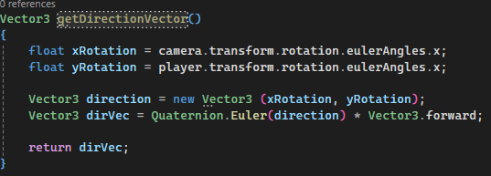
I next began on calculating the direction vector that the ball should be from the player. I made this a separate function for code cleanliness. It should also be noted that the formula to calculate the vector is taken from my earlier research during design.

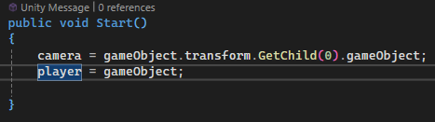
Before running this code however, I had to decide how to fill the player and camera variable. I began with this code below

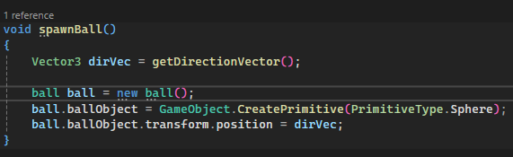
I found that by printing the direction vector, it seemed unreliable and incorrect at points. Yet struggling to debug this, I decided to implement the creation of the ball class first.
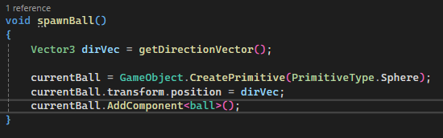
This code however did not work as I was not able to create a new monobehaviour. Instead, I decided that I would create the game object first and apply the ball script onto it
This did run, however faced several issues. The X component was not being accounted for correctly in the slightest and the balls were all being spawned around the base of the player. The latter problem was a simple solution of adding the position of the camera. However the former was much more difficult to diagnose, I immediately concluded that it must be the formula – as I have never used it before. however, decided to check the rest of my code just to be safe.
Through printing the direction vector3, I found that it was a problem with my code, in that I had used the x axis of the player variable when it does not rotate around the x axis. Upon fixing that the code worked perfectly. I could now easily spawn balls as I wished in the correct direction around the camera.
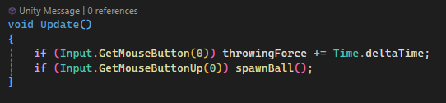
The next step was to implement the ability to hold down left click to throw balls with more power.

This was very easy to implement. And I even found that I didn’t need the “throwing” variable

With this code, I now I had a fully functioning script to throw balls from a position.
Upon testing each axis to see if the code was consistently working correctly, I found two issues. Firstly, old balls were not being deleted when new ones are made and secondly, the throwing force never resets.

With this new code, everything was now actually fully functioning. Although I did make a change for quality of life for the base throwing force to be 1 instead of 0 so the user would have to wait for less time to throw the balls.
I then quickly designed a basic room for the program to take place in, before FINALLY moving onto forces.
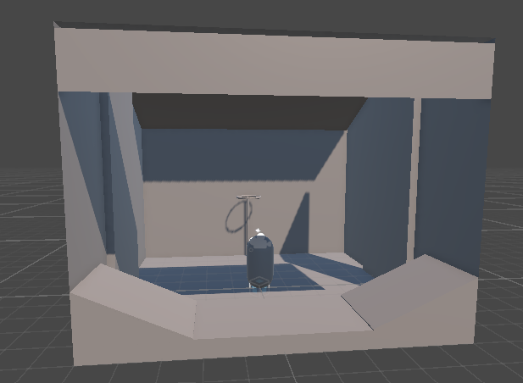
(due to making a shift to blender from pro builder, it was much easier to create the room, allowing me to add the basketball hoop I considered in design)
The room was not perfect but would do well enough.
The first step to forces was implementing gravity – which should be an extremely simple process of making the acceleration 9.81 ms^2 downwards. I however did want to make sure it was stored as a force instead of simply being applied every frame.

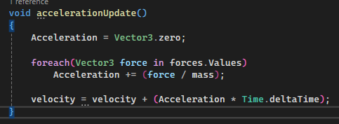
I initially made sure to add it to the forces dictionary, yet this would do nothing on its own. I also had to implement the logic to convert each force into acceleration applied to the ball. This would make the most sense to be its own procedure.

I disliked the naming of the Acceleration variables as it seemed peculiar to be the only attribute with Pascal case naming. I changed it to camel case.
I immediately ran into an issue that all of the variables I declared public were not being filled - mass especially being an issue. I decided to shift to using constant values inside the ball class.
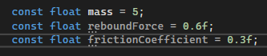
I also noticed that I had both a value for COR and reboundForce – which were essentially the same thing. I removed the COR variable.
(these values are temporary for testing)
I then ran into another error that the dictionary for forces was initially null, I briefly changed both the forces variables and the touchingObjects variable to have a base value of an empty dictionary and list respectively.
This code then worked just fine. I however disliked how slowly the balls throw would charge up, I decided to give it a base offset of 1 and have it increase at twice the speed. This was much more enjoyable.
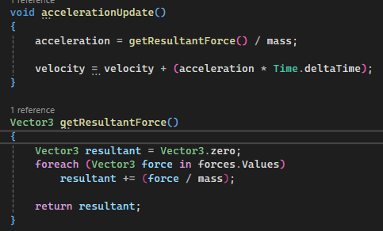
Now I was moving onto the normal reaction force. But first, I had a few things to add. I began by adding the getResultantForce() function and implementing it into my accelerationUpdate() code

This code did have a flaw when tested. I had forgotten to remove the division by mass when combining all forces. With that removed, the code worked.

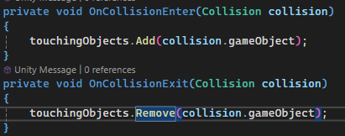
I then started on the collision handling for touchingObjects.

I however knew from previous experience that this code would not be enough. For this to work on any object, it is a requirement that both the object itself and the object being collided with must have both a collider and rigidbody.
I began by applying a mesh / box collider to every object in the room. This worked fine with any other rigidbodies and so I decided to test with the actual ball itself.
(the code to freeze the position and rotation were taken from some research online)
By printing the size of the touchingObjects list with this code, I could see that it was increasing in size when touching another object yet not decreasing at all. I decided to take it a step further and print the gameObject as the ball leaves their collider.
It then worked without explanation on the next attempt, I however still found an error that the ball was colliding with the player initially, I increased the distance from the player in the ballThrow script to make up for it.
Now I could actually begin on the normal reaction force. I decided to follow the plan in design as exact as I could due to the concern I had over just how complicated this may be.
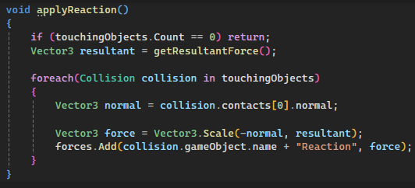
This meant the changing of the touchingObjects variable to work with collisions instead of gameObjects. 0
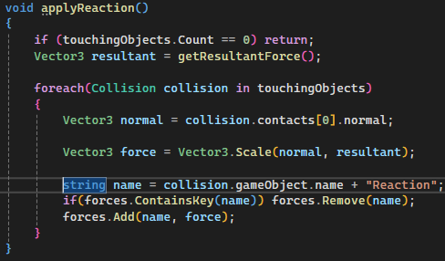
This was the initial code; however it had a large issue, the reaction was not working as there were two keys of the same name in the dictionary. I found that both used the balls name for some reason. I decided to remove duplicate keys to fix this.
This led to my code looking like this. However this code did not work as intended still, mostly due to poor planning. In my design for this force, I entirely forgot to consider that the velocity must be stopped, not just cancelling out the acceleration.
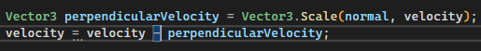
For the sake of saving time, I decided it would probably be beneficial to remove the part of velocity that was moving towards the surface alongside the acceleration. If not, I would have to consider how objects interact on a molecular level which just was not feasible.
I added this line here in the hope of removing the velocity perpendicular to the surface, however it caused the object to speed up instead, therefore I instead added the perpendicularVelocity instead.
This code actually would stop the ball from moving through the floor, however had the issue that it did not correctly work when there were multiple objects touching it. I realised that my ragtag attempt at removing duplicate forces simply did not help the problem at all and decided to take a deeper look at that part of the code.
However, the code made little sense at all. When a void would add or remove the collision, it would store the gameObject collided with, yet this would be entirely different upon applying the reaction force.
I only saw one real option, to change the touchingObjects to a dictionary where gameobjects would act as keys to store the normal of the object they touch.
I now no longer had errors and had a much nicer built system. The velocity and acceleration however now did move the ball in the wrong direction again. I simply flipped the signs for each. The ball now worked at a base functionality
The next step was fixing more of the bugs that had popped up, the two main issues were that the ball could collide with the player to greatly boost itself forwards and that the ball slowly falls into the ground. I decide to change the former first as it was a simple issue of checking the name of the colliding object.
(the new onCollisionEnter method, it checks the keys to ensure that duplicates do not appear in the dictionary alongside the player as well)
The latter was a lot harder to fix, I found from debugging that the acceleration would alternate between the acceleration of gravity and being a zero vector.
This was strange however as the force from the reaction never left the array. I then realised the issue, the resultant force would get set to 0 when the reaction force counteracts other forces, this causes the reaction force to be 0 which then allows acceleration to increase.
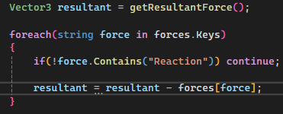
The key to fix this would be not including reaction forces in the resultant force.

This was my fix, removing all reaction forces. And it worked perfectly, allowing the ball to interact with walls and the floor – stopping it correctly. The ball however failed on slopes, being flung in the direction the slope goes up in.
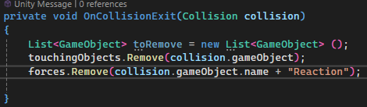
Yet upon further testing, I found that the ball was actually failing on any object that was in the positive direction for some reason. I also found that forces were not being removed from the force dictionary – which makes sense as I only removed from touchingObjects.
Upon adding this, I could now fix the issue with positive values. My first though was that the negative was not working as expected when I use -force as that is the only point where positive values would turn negative.
However, this proved to be incorrect. Printing the values revealed nothing wrong at all. I found instead that by adding the perpendicular velocity, it flipped the result, causing only positive values to work. I printed out the value of perpendicularVelocity and velocity to see if perpendicularVelocity was being calculated correctly. It was not for positive values, instead moving them in the direction of the normal instead of away.
This made sense, as the normal would be negative for negative values, flipping the signs of values. The fix would be to make the normal use absolute values and then choose either + or –.

This worked! By subtracting the perpendicular velocity and using an absolute normal, the reaction force would work correctly… just not for slopes.
Well, more specifically, the gravity wasn’t working for slopes, the ball would stop and just not roll down the slope. This meant that I would have to figure out some way to split the gravity into two components of perpendicular and parallel to the slope.
I found online that I could project onto the plane in the same way I planned for friction for the parallel component and subtract that to get the perpendicular. My plan is that I’m going to change how gravity works, instead of it being a constant value, it will be calculated every frame in comparison to the normal of the objects that it is touching.
The new approach will include splitting gravity into a two vectors - Y and X gravity. the Y representing perpendicular and the X representing parallel
- If touchingObjects is empty, Ygravity is 9.8 downwards. If not…
- Check all touching objects that have a normal with a y component
- Use the normal with the highest Y value (this means that the floor will be prioritised over slopes for when a ball rolls off a slope)
- Calculate the force of gravity perpendicular and parallel to the slope
- Update Y and X gravity.
I started by removing the initial start void that set gravity and made it so rigid. Instead creating an applyGravity() void. I decided it would be best for the gravityX and gravityY to be removed every frame and then set again as they would be different each frame.

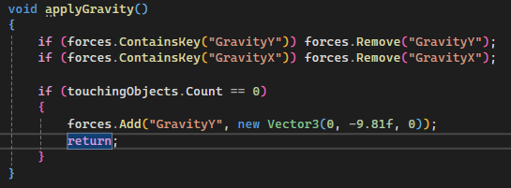
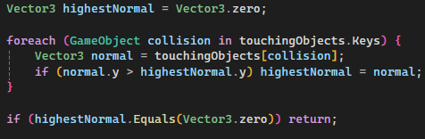
i then could add the initial if statement to set gravity to its basic value if touching nothing. I tested this first and was thankful that I did because I forgot to multiply my mass. With that fixed I could start on the much more difficult part of the procedure.

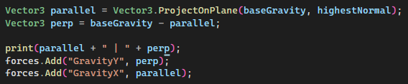
Getting the highest Y value was quite simple, however I now needed to get the x and y component of gravity.
This code worked, however now it was yet again an issue with the reaction force. The y component should be counteracted by the reaction force – and yet was not.
Now this section I cannot fully notate, as it was an hour straight of trying new things to get this code to work and I was so focused on fixing it that I wrote nothing in this document.
The first step in the right direction was removing gravityY and reaction force just for testing purposes as they should cancel each other out and were not.
This code then worked fine for the most part, the ball would slide down slopes without accelerating, however.
I tried a different formula for the reaction force and managed to get it to be the same as negative gravityY. This involved using the Vector3.project function, which I was completely unaware existed.
This did not fix the issue of the ball not accelerating, I looked at the values for velocity and found that it never changed. It took me a while to figure out that was because I was consciously setting it every frame with applyReactionForce()
I changed to only setting the velocity when the ball touched an object but it still would not work, I noticed that the ball was moving up slopes but then in the opposite direction away from the slope.
I tried with a normal that didn’t use absolute values and that didn’t work, still causing balls to fly through walls. And I tried using the Vector3.project() function and that didn’t work either. Yet using both together finally made the code work to calculate velocity perpendicular to the surface and negate it.
I would like to note that the reaction force took me 4 days to get working. Far longer than it ever should have, and throughout that time I lost a serious amount of motivation in this project.
This project was delayed to the end of the month as I focused on other parts of my life and now it was the 27th may. I was convinced that I would never be able to do this.
Yet something about seeing that ball roll across the slopes made me feel so incredibly overjoyed, I no longer believed in finishing this project in the way that I had before. However, I still wanted to see just how far I could go in the small amount of time left.
Due to the fact that I struggled so greatly on the reaction force, I decided I would try out a new method to map out what I had to do for friction before implementing it.
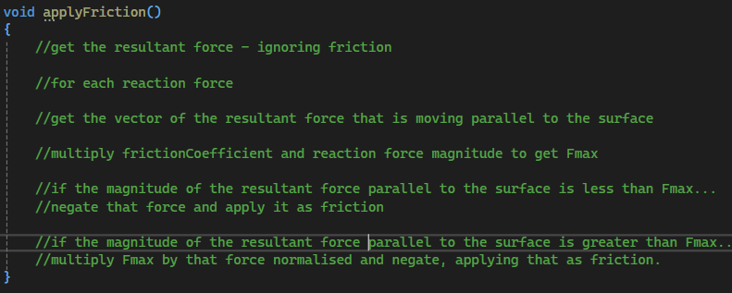
Now, all I had to do was go though and implement each of these comments as actual code.
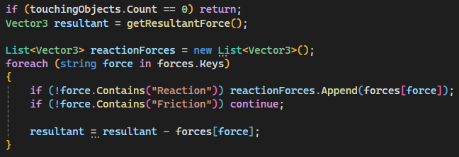
the first step was simply the copying of the code that starts the reaction force procedure. Creating a resultant force without friction in this case. However, I also used the same foreach loop to get all reaction forces inside the forces dictionary – this would be extremely helpful for the next part of looping through each reaction force.
I did however realise that I would need to change this to a string list so that I could give the force a name that matches the object it touches.
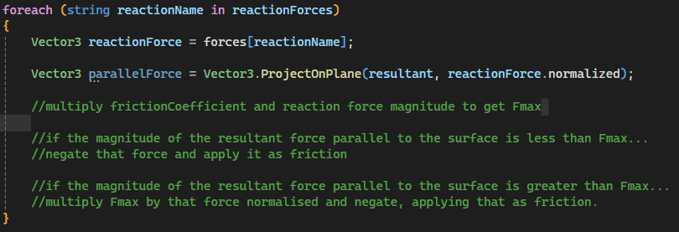
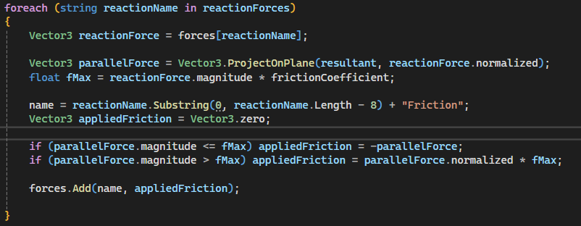
I then implemented the foreach loop and calculated the force parallel to the surface by normalising the reaction force and using it as a direction vector.
and by finishing off the code, I now had what would hopefully be fully functioning friction. The only improvised part of this was getting the name, which I found by creating a substring of the reaction force name until the final 8 letters which would of course be “Reaction”
My first test was a failure, I immediately noticed that the reaction forces were being added if they weren’t reaction forces instead of if they were and decided to log the applied friction.
I found that the code was never actually reaching the point of applied friction, I decided to print the process of calculating the resultant force to see if that had an error causing no reaction forces.
I found that it was looping through all of the forces correctly and checked if the resultant force list was empty – it was, ensuring that something must be wrong with the checking for reaction forces.
I used a separate if statement to check for the reaction and found that it worked just fine. The next step was to check if the process of appending actually worked. I checked and it seemed to be doing nothing, I changed to using the add() method and it correctly worked.
I then ran into an issue with duplicate keys and fixed it the exact same way I fixed it with reaction force.
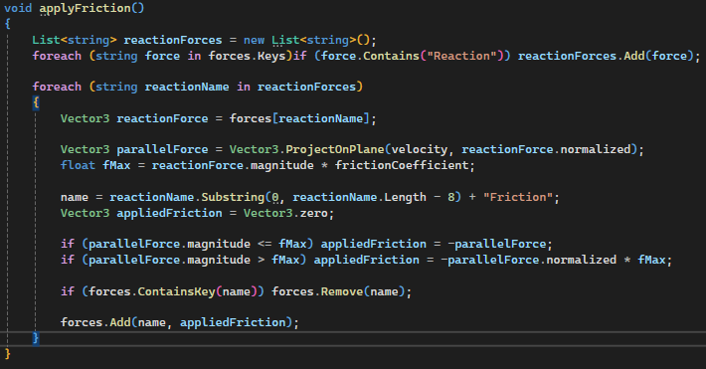
Then came the issue that I was using resultant force which does not guarantee to have a non zero value. I pivoted to using velocity instead that would work much better. And changed the normalised parallel force to be negative as I had forgotten to add that.

this was the current state of the method, it worked exactly as it should for a single reaction. But when touching a specific wall in the room, the ball worked completely incorrectly, somehow accelerating parallel to the wall after stopping due to friction. I wanted to check which of the two Fmax if statements were running, as the first should stop behaviour like this when velocity is too low. I realised that it no longer would though due to the shift to changing the force based off of velocity.
Furthermore, I found that using solely the second statement would work perfectly fine until the ball slowed down – where it would jitter.
By this point though, my time was up. The Project could no longer continue, and I was frankly incredibly upset for allowing this to happen. However, I believe there is a much more positive conclusion to draw from this project.

CONCLUSION
So before I reach a final conclusion, I would like to begin by stating my thoughts on this project. I would like to begin by saying that I do not see this project as a failure in the slightest! Yes, I did not finish it, however I still implemented gravity and reaction forces - documenting every last step of it. To just classify this entire program as a “failure” would completely invalidate all of the hard work I poured into this project as I tried to make it as good as it possibly could be.
So, what went wrong? Well, I believe there are a few different factors that lead to this.
- Feasibility study. In this project, the feasibility study was treated more as a formality then something that would actually recognise issues. Where my prior project succeeded and this did not was planning for the future, I recognised risks before and took steps to prevent them, in this project I simply treated each issue as something that I could overcome.
- The biggest flaw in my opinion in this entire project was that it never should have been programmed in 3D. I was so incredibly caught up in trying to make the program look interesting that I forgot just how important it was for it to meet my aims of reinforcing my academic knowledge – where all problems are in 2D
- I also had not done enough in class for this project to work, thus far in our course we have never done kinetic friction that slows a ball down, this lead me to be incredibly confused when the friction was not working the way I expected it to.
- All of this could have been manageable, if it just were for better planning. In my attempt to reduce the amount of writing for this project, I only complicated it further by not planning enough and rushing into implementation – this lead to me writing the same amount in the end anyway.
Now most of these issues were directly caused by my own lack of experience, I did not have enough experience in mechanics, and I did not have enough experience in working with the waterfall methodology. However, I would also like to note how the methodology affected this project.
- Very easy time planning. At the very start of the project, I already had deadlines of what to work in and could follow these through until the very end if so wished.
- Inability to go back to a previous stage of development. I realised close to the start of implementation just how difficult it was to work in 3 dimensions, but I simply could not go back and change it by that point. The structure simply was not flexible enough.
All in all, I would say that I did not enjoy using the waterfall methodology very much for my own personal projects. However, when attempting to program something in a very limited amount of time, I could see how it may be extremely beneficial.
The next project that I have planned in this study is to do a comparison of Primm’s vs Kruskal’s whilst learning HTML and JavaScript. I am currently debating on whether or not I will go through with it after seeing how much a lack of knowledge affected this project, that will be discussed in the next document. Thank you very much if you have chosen to read to this point, I will see you in the next project!

